Lifegroup Questions
26 I will give you a new heart and put a new spirit in you; I will remove from you your heart of stone and give you a heart of flesh. 27 And I will put my Spirit in you and move you to follow my decrees and be careful to keep my laws. Ezekiel 36
- A general question. The speaker on Sunday said that ‘we often don’t like change in our lives’. Share a time in your life when that was true and a time when change worked out very well.
- Read the passage above, John 3:3-6, 2 Cor 17, Rom 2 12 and 1 Cor 15:51-53). If you had to, which one would you choose to talk to a non-believer about lives being transformed by Christ? How would you start the conversation?
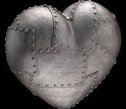

- Two hardened hearts, one stony and one armoured. What sort of things might cause us to have hardened hearts? What can we do to prevent getting hard hearted?

4. The speaker said that we can only really change through the work of the Holy Spirit in our lives and that should ask Him - often. Luke 11:11-13. How often should we ask?
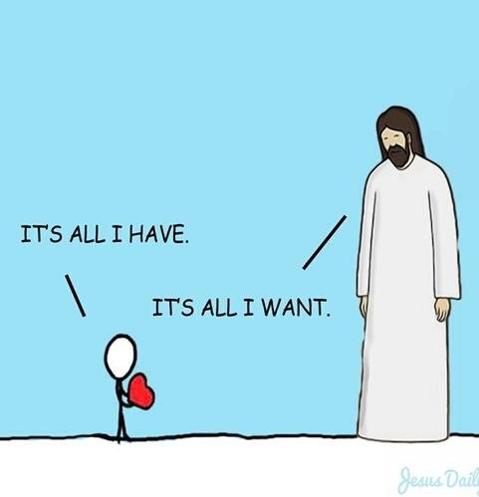
5. Is the picture below ‘right’?

6. In 6 months time it will be high summer, late July. From now to then, think about what you would like God to change within you. For inspiration read Gal 5:22-23. You may want to put a note in your diary for 6 months time to see what has changed…and start praying now…

