Bible Study Questions – FBC Life Groups Week commencing 01/03/26

Icebreakers – When did you last see a rainbow and what was your circumstances & reaction at that time?
Or
List in the group some of God’s other amazing promises…………..
Favourite one to you and why?

Also, some questions you may wish to consider collectively:
1. How does God's instruction to Noah reflect His merciful nature?
2. What does Noah's obedience to God tell us about his character and faith?
3. How does the gathering of animals in the ark symbolize God's care for all His creation?
4. How do you interpret God's decision to flood the earth and destroy all life?
5. What significance does the number "40" (as in forty days and nights of rain) hold in this context?
6. What lessons can we learn from Noah's unwavering faith when faced by a global calamity?
7. How can we understand the closing of the ark's door by God Himself?
8. What does it mean to be "righteous in this generation," as Noah was?
9. What practical steps can you take to demonstrate faith & obedience as Noah did, Jo suggested some ideas on Sunday, but you may have more insights & tips to share?
10. What lessons can we learn from the contrasting reactions of Ham, Shem, and Japheth to their father's vulnerability?

Consider again the personal questions posed at the end of the preach. Would anyone like to share with the Life Group - your thoughts, situation, prayer requests relating to these – a day or so on now?

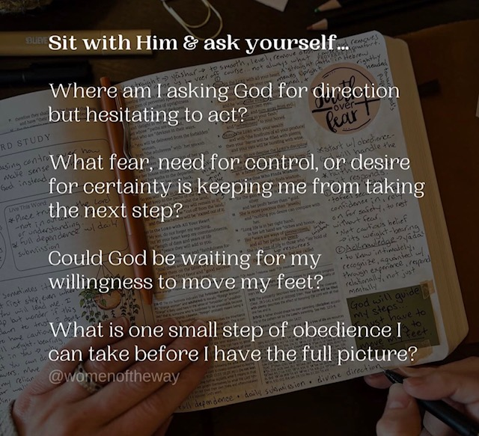

Finally, you may wish to listen to or use again in some way in your group the song played – see the attached link
https://www.bing.com/videos/riverview/relatedvideo?q=your+labour+is+not+in+vain+lyrics&mid=EB80868EE860B4F22603EB80868EE860B4F22603&churl=https%3a%2f%2fwww.youtube.com%2fchannel%2fUCuWPn2sw5aOzA000qcFQVZQ&FORM=VIRE

